FLEET SERVICES
PLAN AND POLICY

TABLE OF CONTENTS

APPENDIXES………………………………... 3
GLOSSARY…………………………………...4

EXECUTIVE SUMMARY………………….. 5
Authority ............................................................ 5
Plan Scope........................................................... 5
Administration Plan…………………………… 5
Maintenance Plan.…………………………….. 5
Organization and Operations Plan.......................6
Fleet Management……………………………...6

I: VEHICLE ANALYSIS...............………….. 7
Activities ……………………………………... 7
Fleet Right Sizing Evaluation.………………… 7
Develop Fleet Assessment Report.……………. 7
Associated Policies and Guidelines.……………8
Vehicle Utilization and Minimum Use…………8
Vehicle Replacement Guidelines……………… 9
Repair Expenditure Limits.…………………... 10
Replacement & Repair Table…….……………10
Clean Fleet Goals……………………………..10

II: BUDGETING………..…………………...11
Capital Improvement Plan…………………….11
Vehicle Requests.……………………………..11
Vehicle Asset Assignment…………………….12
Vehicle Rates……............................................ 12

III: ACQUISITION. ...…..…..……………… 13
Activities ...…………………………………...13
Vehicle Acquisition...........................................13
Associated Policies and Guidelines...................14
Operational Fleet Sizing.…...............................14
Vehicle Acquisition Limit.................................14
Vehicle Upgrade ……………………………...14

IV: VEHICLE PREPARATION…………....15
Activities…………………………………….. 15

Receiving Vehicle……………………………….. 15
Vehicle Registration …………………………….. 15
Up-Fitting ..………………………………………15
Vehicle Assignment ……………………………...15
Take Home Vehicle Policy...……………………..16

V: FLEET OPERATIONS…………..………….17
Fleet Services Manager Activities.…..…………...17
County Policies and Procedures………..................17
Departments Responsibilities ................................ 18
Vehicle Maintenance and Repair…………………18
Roadside Assistance....…………………………... 18
State Vehicle Inspection.. .………………………. 19
Trip Logging...........................................................19
Vehicle Idling Policy ………………….................19
Vehicle Fueling..………………………….............19
Alternative Fuel Vehicle………………………….19
Fuel Card Program….…………………………… 19
Bulk Fuel Contract.……………………………… 20
Other Gasoline Fuels.……………………………. 20
Fleet Operator Guidelines...……………………... 21
Communications………………………………….21
Maintenance and Repairs....................................... 21
Vehicle Use.............................................................21
Motorpool Management .………………………... 21
Motorpool Rate …….………….............................22
County Travel Policy……………………………..22
Fleet Management Program...…………………….22
Car Care...…………………….…………………..22
Vehicle Accident Policy………………………..... 23
Vehicle Disposal....………..…..………………….23

VI: FLEET MANAGEMENT…………….……24
Data Analysis and Reporting……………………..24
Vehicle Rotation.…………………………………24
Monthly Mileage Reporting...…………………… 24

APPENDIXES

Vehicle Life Cycle ....................................25
Vehicle Evaluation Form …………....…..26
Vehicle Request Form…………………...27
Vehicle Rate Table………………………28
County Insurance Policy……...………….29
Mexico Insurance Policy...………...…….30
Waiver of Liability……………………… 31

Roadside Assistance………………….32-34
Vehicle Service Request…………………35
Motorpool Reservation Form……………36
Accident/Damage Report…………….37-38
Supervisor’s Investigation Report……….39
Take Home Vehicle Assignment Form….40

GLOSSARY

CAMS: Cascade Accounting Management System is the program Fleet Services uses to manage the fleet.
Car Care: Reasonable expectation to prevent damage through neglect or carelessness.
Car Wash: Maintaining a vehicle state of cleanliness and sanitation.
CEO: County Executive Officer.
Charge Back: Amount billed to departments directly for parts or services.
County Vehicles: Group of vehicles belonging to Imperial County Fleet Services that is available for lease.
DOV: Department Owned Vehicle purchased by a department or acquired through a contractual obligation with a third party or grantee.
Depreciation: Method for allocating the cost of fixed assets to periods benefitting from the use of an asset.
FBR: Full Burden Rate is the allocation rate which indirect costs are applied to the direct costs of either labor or inventory.
Fleet Services: Department appointed by the County of Imperial Board of Supervisors to manage vehicles.
General-Purpose Vehicle: A vehicle assigned for routine official county business.
GSA: General Services Administration appointed by the County of Imperial Board of Supervisors to manage budgets and fiscal responsibilities.

ISF: Internal Service Fund established to finance, administer, and account for departments or agencies of a government whose exclusive or nearly exclusive purpose is to provide goods or services to other departments on cost-reimbursement bases.
Law Enforcement Vehicle: Vehicles that conduct routine patrols in the outlying areas of Imperial County.
Loss Reserve: Estimate of liability for future claims that is under the administered by Human Resource/Risk Management.
Mileage Rate: Amount charged per mile for operations, maintenance and replacement of a vehicle.
Motorpool Vehicle: Centrally managed group of vehicles intended for the use of county personnel to augment their department.
N/A: Not applicable.
Special Vehicle: Vehicles that meets specific needs of a department.
Subrogation: The County claim process for reimbursements of damages.
TBD: To Be Determined.
Vehicle Category: Classifies types of vehicles.
Vehicle Preventative Maintenance: Scheduled servicing, inspections and repairs to provide safe, reliability and economical vehicles.
Vehicle Repair: General restoration of a broken, damaged, failed devise, equipment, or part to an acceptable usable condition.
YTD: Year to Date.

EXECUTIVE SUMMARY

AUTHORITY

Imperial County Board of Supervisors shall direct the Fleet Services Manager to develop a Fleet Management Plan and make recommendations for improving the administration and operation of the fleet. The Imperial County Fleet Services Plan and Policy addresses each component of the fleet and provides direction to implement provisions of the plan. The Fleet Services Plan and Policy employs a methodical approach to fleet management.

PLAN SCOPE

The Plan Scope applies to all county vehicles.

- The number and types of vehicles and the purpose each vehicle serves;
- Procedures to increase vehicle use and improve efficiency;
- Procedures to reduce the cost of maintaining vehicles;
- Opportunities for consolidating and “pooling” of vehicles.

All vehicles are subject to requirements of the plan. Departments that purchases a vehicle with non-
appropriated funds (such as grants) are subject to all requirements of the plan and/or grantee specific requirements.

ADMINSTRATION PLAN

The Administration Plan provides necessary management and support for all fleet operations. Ensures adherence to all county directives and policies, provide guidance and oversight for all fleet functions, ensure compliance with federal, state, and local standards and regulations, and maintains required documentation and record keeping.

MAINTENANCE PLAN

The Maintenance Plan operates as “Zero Net Cost” which encompasses all aspects of the Vehicle Life Cycle. The plan will provide safe, reliable and economical vehicles. The Fleet Services Manager will administer an annual review of the plan and recommendations will be presented to the Imperial County Board of Supervisors.
ORGANIZATION AND OPERATIONS PLAN

This Organization and Operations Plan reinforces a Vehicle Life Cycle management process and provides recommendations on how departments may standardize their respective Vehicle Life Cycle management processes. The plan analyzes and provides recommendations on all aspects of vehicle and equipment, which includes safety, utilization, depreciation, maintenance costs, replacement costs, standardization, and determines best methods for replacement and acquisition of vehicles. Analyzes and makes recommendations regarding requests for vehicles standardization and optimal match of needs and resources. Evaluates contracted work and invoices for work performed on fleet vehicles for compliance, resolves discrepancies, and makes recommendations for contract modifications. Communicates with county departments who utilize fleet vehicles to explain policies and programs, secure acceptance of, and support on the policies and programs, ensure compliance, and respond to complaints and requests for information. Analyzes departmental vehicle needs and advises departments on equipment suitability and possible use of alternative types of vehicles by considering cost and use factors and other available information.

VEHICLE LIFE CYCLE

Vehicle Life Cycle summarizing key phases of the life cycle that utilizes the overall organizational structure for this plan. Each section of the plan provides departments with a summary of the phase of the Vehicle Life Cycle and provides an overview of key processes associated policies and guidelines.

APPENDIX A: Vehicle Life Cycle

FLEET MANAGEMENT

Imperial County Fleet Services plays a central role in the support of the Vehicle Life Cycle. Key functions of the Fleet Services Manager includes:
- Create and implement the Fleet Management Plan with approval of the Imperial County Board of Supervisors and review the plan annually;
- Collect and analyze fleet data;
- Establish, implement, and monitor fleet management guidelines;
- Assist as needed in the development of budgetary reports;
- Serve as focal point of contact between departments and other fleet management related responsibilities;
- Assist with developing strategies to provide acquisition of vehicles and other fleet related services;
- Offer fleet management support through publications, web page, meetings, and other forms of communication as needed;
- Identify and share best business practices for fleet management activities.

I: VEHICLE ANALYSIS

The Fleet Services Manager and Department Directors will determine if the number and types of vehicles currently deployed in the fleet are meeting the Fleet Services Plan and Policy requirements.

ACTIVITIES

- Perform a Vehicle Replacement Evaluation
The Fleet Services Manager shall evaluate the fleet annually to identify vehicles that meet replacement criteria, of vehicles with excessive repair, maintenance, or operating costs. The Fleet Services Manager shall utilize all available data of the fleet, including internally tracked data when evaluating vehicles for replacement.

APPENDIX B: Vehicle Equipment Evaluation Report

- Conduct Fleet Right Sizing Evaluation
The Fleet Services Manager shall perform a fleet “Rightsizing” to help determine their appropriate fleet size and composition to prevent underutilization. Factors to consider in sizing a department fleet (in terms of both overall number of vehicles and vehicle type) are the department mission and whether the need will be short-term (perhaps met by rentals or Motorpool units) or long-term (perhaps met by lease or purchase). When conducting a “Right Sizing”, one of the main factors considered should be whether current vehicles are underutilized.

In analyzing fleet composition, the Fleet Services Manager shall evaluate the vehicle application, number of passengers typically carried, special needs of the operator, and any limiting factors (e.g. towing, payload, seasonal use) of current vehicles.

- Develop Fleet Assessment Report
The Fleet Services Manager will document findings derived from the Vehicle Needs Evaluation and Right Sizing Evaluation in a report. The report should outline recommendations for replacement, realignment or disposal of existing fleet vehicles and any identified needs for new fleet vehicles. The report should include details of the analyses performed, and policies, criteria and/or best practices used in developing recommendations. Development of a Vehicle Replacement Plan which addresses both short and long-term replacement needs and help the county to prevent and/or eliminate backlogs of deferred replacements and provides management with a predictable level of annual funding requirements.
ASSICIATED POLICIES AND GUIDELINES

- Vehicle Utilization and Minimum Use
Minimum use guidelines apply to most vehicles to ensure departments are getting the optimal use of vehicles. The minimum mileage target for vehicles (sedans, pick up, vans and other vehicles intended primarily for carrying passengers to include Law Enforcement) is 7,500 miles annually. The Fleet Services Manager shall develop and distribute department-specific reports, based on reported fleet data, to flag vehicles that have accumulated less than the minimum mileage for the designated reporting period. The Fleet Services Manager with Imperial County Board of Supervisors approval may amend this minimum mileage target when determinations are made to enhance fleet operations. The Fleet Services Manager shall establish other suitable minimum use criteria when appropriate.

The intent of this requirement is to call attention to vehicles that are underutilized. It is not to direct departments to drive vehicles solely for putting mileage on them to attain a minimum mileage level. The report will assist departments evaluating their vehicle utilization to ensure that all vehicles are being effectively used and identify vehicles may not meet the annual utilization requirement.

a. The following vehicles are exempt from minimum use criteria:
Department owned vehicles and vehicles with a manufacturer’s Gross Vehicle Weight Rating (GVWR)
of more than 8,500 pounds, construction heavy equipment vehicles purchased with federal, state or
local grants and vehicles granted waivers by the Fleet Services Manager.

Departments will have 30 days from the Fleet Services Manager report to submit written justification
for retaining vehicles that fail to meet minimum use criteria. Extensions granted by the Fleet Services
Manager for departments to justify special use vehicles not identified in the exemptions list.

b. Departments justification may include, but is not limited to:
  - What is the primary function of the vehicle and how does this relate to the core function of the department?
  - What services are provided through use of the vehicle?
  - How many passengers are carried and how many trips per month?
  - What is the cost to utilize the Motor Pool comparable vehicle for the same number of days or trips compared to the cost of ownership?

The Fleet Services Manager may provide waivers for specific vehicles based on justification information submitted by a department. The Fleet Services Manager may grant a lifetime waiver to a vehicle determined to be so unique in its function or design that a department is unable to use the vehicle for any other purpose or to rotate the vehicle within the fleet.

2. Vehicle Depreciation
Due to current changes implemented by the State Controller's office based on Title 2 of the Code of Federal Regulations (CFR) Part 200 and in accordance with General Accepted Accounting Principles (GAAP) depreciation.

The Auditor-Controller has determined that passenger vehicles will be depreciated over a 5-year (60 months) period, while law enforcement vehicles will be depreciated over a 3-year (36 months) period.

Effective December 26, 2014, mileage use allowance was no longer acceptable as a substitution for depreciation. The Auditors' office has converted county vehicles on hand to the Straight Line Depreciation method (based on actual costs).

3. Vehicle Replacement Guidelines
Fleet Services Manager consideration for vehicle replacement is focused on safety and may make exceptions to the replacement guidelines on a case-by-case basis. For example, vehicles may be replaced sooner if they incur excessive maintenance or repair costs or may be retained longer if they have unusually low maintenance costs. Specialized equipment may require the use of customized replacement guidelines.

- Condition – The overall safety and functionality of the vehicle.
- Miles – Total amount of miles the vehicle has been driven.
- Age – Determined by the vehicle build date.
4. Department Owned Vehicle Replacement
Department Owned Vehicles will adhere to Fleet Services Vehicle Replacement Guidelines. The Department Director will notify Fleet Services of specific requirements prior to replacing vehicles and will be solely responsible for all funding requirements.

If a Departments Director that decides to keep a vehicle in service past its useful service life, Fleet Services will continue collecting the Board Approved vehicle rate(s). However, the department will be responsible for all major repair costs (e.g. Engine rebuilds, transmission rebuilds, electronics, etc.). Vehicles determined to be unsafe will immediately be removed from service.

Vehicle replacement funding collected shall be applied exclusively for the approved vehicle replacement plan as directed by the Board of Supervisors. Vehicles purchased which are exclusively for the use of a specific grant program and the grant guidelines or provisions require no vehicle replacement funding is allowed; the vehicle replacement funding will be refunded; only when all operation, administration and overhead costs are fully recaptured for the life of the vehicle.
5. Vehicle Replacement & Repair Expenditure Limits
The one-time repair expenditure limits for vehicles as indicated in the attached table are applicable to each
repair job performed on the vehicle. These repairs will not include routine maintenance and repairs. The accumulated repair expenditure limits for vehicles will include the cost of all major repairs performed on the vehicles. Work performed by outside vendors will be on an actual cost basis. The accumulated expenditure repair limit is based on the actual acquisition cost of the vehicle, excluding accessories, special equipment and other special costs.

Max Repair One-Time Repair Expenditure in Years
Life Mileage Limit % of
Vehicle Type Expectancy Expectancy Vehicle Price 1 2 3 4 5 6 7 8 9 10__
Law Enforcement 4 125,000 % 90 80 70 60 50 40 30 25 25 25
Sedan Mid-Size 10 125,000 % 90 80 70 60 50 40 30 25 25 25
Sedan Full Size 10 125,000 % 90 80 70 60 50 40 30 25 25 25
SUV Mid-Size 10 125,000 % 90 80 70 60 50 40 30 25 25 25
SUV Full Size 10 125,000 % 90 80 70 60 50 40 30 25 25 25
Truck Mid-Size 10 125,000 % 90 80 70 60 50 40 30 25 25 25
Truck Full Size 10 125,000 % 90 80 70 60 50 40 30 25 25 25
Van Mid-Size 10 125,000 % 90 80 70 60 50 40 30 25 25 25
Van Full Size 10 125,000 % 90 80 70 60 50 40 30 25 25 25
Special Vehicles TBD **************************************************************************

7. Clean Fleet Goals
Imperial County Clean Fleet Goals will drastically reduce harmful greenhouse gases and phases out internal combustion engines in California’s fight against climate change. To support the transition away from fossil fuels, California’s Governor Galvin Newsom Executive Order (N-79-20) requires 100 percent of in-state sales of new passenger cars and trucks will be zero–emission by 2035. Consistent with the goals established in the Order, California’s goal is to be carbon neutral by no later than 2045 or to the most current legislation. Pathway for carbon neutrality requires all replacement vehicles or newly introduced vehicles incorporate one or more of the following advanced smart fuel-efficient technologies and year over year zero emission vehicles shall be introduced into the fleet.
- Electric Vehicles | - Valve Timing & Lift Technology | - Dual Clutch Transmission
- Lower Displacement Engine | - Additional Transmission Gears | - Direct Fuel Injection
- Cylinder Deactivation | - Continuous Variable Transmission | - Start Stop Systems
- Hybrid/Plug In Hybrid | - Mild Hybrid | - Turbocharging

II: BUDGETING

The Fleet Services Manager and Department Directors will evaluate the recommendations derived from the analysis performed in Phase I in an effort to construct a fleet related budget request.

CAPITAL IMPROVEMENT PLAN

1. Develop Business Case
The Capital Improvement Plan is the primary method to request funding:
- The County will purchase only base model vehicles;
- Review recommendations/request for vehicles;
- Determine the number and category of vehicle to be replaced;
- Acquire pricing and formulate an estimate of funding needed to replace vehicle;
- Determine if the types of vehicles considered for acquisition meet specific requirements;
- Department Directors are required to submit a Vehicle Request Form to upgrade vehicles that require specific features or vehicle acquisitions over $35,000.
Departments should consider the following when requesting vehicles
- Can existing vehicle be reassigned to fill the need?
- Will the new vehicle meet minimum use requirements?
- Is there is a cost savings (e.g. renting motor pool vehicle, leasing/rental car company)?
- Reduce monthly vehicle stipends and reimbursements and utilize county assigned vehicles?
2. Vehicle Requests
Departments requesting an additional vehicle to their fleet or requests a change to the type of vehicle or
upgrades is required to submit a Vehicle Request Form. The Imperial County Board of Supervisors shall
approval/disapproval the Vehicle Request with recommendations from the CEO and Fleet Manager.

APPENDIX C: Vehicle Request Form

3. Vehicle Asset Assignment
The main objective of asset assignment is to effectively manage the fleet and maintain accurate accounting
of assets.
- Vehicles purchased utilizing General Funds will be assigned to Fleet Services.
- Vehicles purchased through a grant/special funding will be assigned to the department.
- Department Directors can request the Board of Supervisors to assign grant/special funded vehicle to Fleet Services contingent on grant/special funding requirements.
- Grant/special funded vehicles identified for replacement and General Funds subsidized operating the vehicle, the replacement vehicle will be assigned to Fleet Services contingent on grant/special funding requirements.

4. Vehicle Rates
Annual review of the Vehicle Rates is required to ensure necessary funding for sustainability of the fleet. The Vehicle Rates shall recapture all costs to provide safe, reliable and economical vehicles.

- Operation & Maintenance – Cost for Fleet Operations, Fuel, and Maintenance.
- Replacement Rate – Cost for the replacement of vehicles and or lease to own.
- Total Rate – Operation, Maintenance and Vehicle Replacement Rates combined.

APPENDIX D: Vehicle Rate Schedule

5. Fleet Services Facility
The Fleet Services Manager shall develop a Capital Improvement Plan (CIP) for the maintenance and replacement of property, structure maintenance and replacement, equipment maintenance and replacement, vehicle maintenance and replacement. Funds collected in excess of 60 days working capital will be directed to the Fleet Services Reserve Fund to finance CIP projects.

III: ACQUISITION

The Fleet Services Manager and Department Directors will acquire vehicles in accordance to the Imperial County Fleet Services Plan and Policy. Certain vehicles may require exceptions based on special use requirements and construction and the vehicle specification requirements will be submitted to Procurement and the CEO office for review.

APPROVAL

The requesting department must submit a Board Agenda Fact Sheet, Vehicle Request Form and supporting documents to the Imperial County Board of Supervisors for approval/disapproval.

ACTIVITIES

Vehicle Acquisition

The Department Director and Fleet Services Manager will determine vehicle specifications from the Fleet
Right Sizing Evaluation and seek to acquire vehicles in the most cost effective manner available.

A. Options for acquisition include:
- Purchase through county bidding process;
- Purchase through state contract or other approved methods;
- Purchase of surplus or seized vehicles;
- Lease to Own Plan;
- Acceptance of a donated vehicles.
B. The County should consider alternatives to vehicle acquisition including:
- Rental of vehicles will be used only to meet temporary, short-term, and/or seasonal requirements. Departments should consider vehicle acquisition if the requirement for transportation is ongoing. Vehicles rented by departments for short-term requirements (generally shorter than one month or for a specific requirement, e.g. contingency operations) are not subject to data collection and plan requirements.
- Use of utility carts instead of licensed vehicles where appropriate. Utility or golf cart type of vehicles can be useful instead of trucks or other licensed vehicles when used exclusively in complex environments.

- It may be cost effective to outsource special purpose vehicle (e.g. forklift) through a contracted vendor on an as-needed basis rather than to own such a vehicle.
- Mileage reimbursement (Current Standard IRS Rate) for the use of personal vehicle option may be more cost effective. Fleet Services Manager shall conduct reviews of the feasibility of alternatives to County owned vehicles, including leased and rental vehicles. Review findings will be presented to the Imperial County Board of Supervisors.

ASSOCIATED POLICIES AND GUIDELINES

- Operational Fleet Size
The Fleet Services Manager monitors the fleet size and makes necessary recommendations to the imperial
County Board of Supervisors to maintain, reduce or increase the fleet.

2. Pool Vehicles
The Fleet Services Manager and Department Directors will periodically evaluate opportunities to consolidate multiple departments within the same geographic area. Such methods will increase vehicle use and improve the efficiency of the fleet.

3. Vehicle Acquisition Limit
Vehicle Request Forms and supporting documents must be submitted to the CEO’s office for vehicle acquisition of $35,000 or more. The CEO will approve/disapprove the request prior to the Vehicle Request Form and supporting documents are submitted to the Imperial County Board of Supervisors.

4. Vehicle Upgrade
Departments that request a Vehicle Upgrade must complete a Vehicle Request Form and submit it to the CEO for authorization. The department will be responsible to provide funding for the upgrade.

5. Local Vendor Preference Policy
Refer to County of Imperial Local Preference Policy.

APPENDIX C: Vehicle Request Form

IV: VEHICLE PREPARATION

The Fleet Services Manager and Department Directors will prepare vehicles for use in the fleet. This includes the addition of such equipment as seals, stripes, radios, computers, emergency lights, logos, decals and painting as applicable. Departments should allow necessary preparation time to ensure all added equipment and features are installed and working properly. Departments requiring special equipment will be responsible for all associated costs to purchase, installation, maintenance and repairs.

ACTIVITIES

1. Receiving Vehicles
The Fleet Service Manager and Department Director will inspect vehicles before they are placed in service. Special care should be taken to make certain that the vehicle meets all specifications requested during acquisition process prior to accepting the vehicle.

2. Vehicle Registration and Insurance
Purchasing and or Departments Directors are required to keep vehicles properly registered with the Department of Motor Vehicles. The Risk Manager will ensure that the County Vehicle Insurance Policy is current and Fleet Services/Department Directors will place a copy of the Insurance policy in the vehicle prior to placing the vehicle into service. Most County owned vehicles are required to obtain exempt plates. County vehicles requiring “Cold Plating” will be the responsibility of the assigned departments.

APPENDIX E & F: County Insurance Policies

3. Up-Fitting
Fleet Services shall make the vehicle ready for service by installing or out sourcing required aftermarket equipment and apply county and department required logos (inscription required on all county owned motor vehicles and heavy equipment) on all vehicles and equipment with exempt plates. Certain unmarked law enforcement vehicles and vehicles with Non–Exempt plates are exempt from this requirement. Departments requiring special equipment shall be responsible for all costs of purchasing, installation, labor, maintenance, repair and replacement.

4. Vehicle Assignment
Departments are required to assign fleet vehicles to a specific location, unit and/or individual in an effort to properly account for, track and monitor the vehicle.

5. Take Home Vehicle Assignment Policy
Assignment of a vehicle to an individual employee on a permanent or daily basis is prohibited without written documentation on file with the County Executive Officer and Department Director. The Department Director is required to validate the assignment is critical to the mission of the department.

The Department Director assigning a vehicle to an individual employee shall document the following information at a minimum: Vehicle Identification number, license plate number, year, make, model and fuel cards. Name and position of the individual to whom the vehicle is assigned (except in case of law enforcement officers where disclosure of this information could jeopardize the individual’s safety or security) Justification of the assignment with regard to the mission of the department or agency.

APPENDIX M: Take Home Vehicle Assignment Form
V: FLEET OPERATIONS

The Fleet Services Manager and Department Directors are required to operate fleet vehicles in accordance to the Imperial County Fleet Services Plan and Policy.

FLEET SERVICES MANAGER ACTIVITIES

1. Develop County Policies and Procedures
Fleet Services Manager shall develop and maintain written policies and procedures governing operations. These policies and procedures will be made available and kept current. Departments are encouraged to adopt practices specific to their fleets. Any additional policies and procedures must be consistent with the requirements of the plan, and be vetted by the Fleet Services Manager and Risk Manager prior to adoption. Vehicle Operation Policies and Procedures shall address.

  - Develop county policies and procedures
  - Commitment to provide staffing support
  - Appropriate use of county vehicles
  - Vehicle assignment and motor pool procedures
  - Procedures for determining vehicle needs
  - Assist with driver eligibility requirements
  - Vehicle acquisition
  - New vehicle delivery
  - Preventive maintenance
  - Vehicle repair
  - Warranty tracking
  - Fuel management
  - Accident reporting
  - Timelines for performing replacement analysis
  - Vehicle replacement schedules
  - Use of personally-owned vehicles
  - Vehicle disposal

APPENDIX G: Waiver of Liability
2. Department Responsibilities
The Department Director will appoint an individual as the point of contact (POC) for their department. The POC shall serve as the principal contact for the Fleet Services with regard to fleet related matters. Department Directors are responsible for ensuring the Fleet Services is supported in implementing and enforcing this plan and policies

3. Vehicle Maintenance and Repairs
Fleet Services shall properly maintain vehicles as necessary to keep fleet vehicles in proper working condition. Proper maintenance and repair of vehicles includes the following:

a. Preventive Maintenance
Departments will follow preventive maintenance schedules for all vehicles in accordance to the Fleet Services Manager directives. A mileage service label will be placed in the driver’s dash area to alert for the next service. When the vehicle has reached the required mileage for service, the department POC will have the vehicle delivered to Fleet Services.

b. Preventive Maintenance Compliance
A late fee of $25 for every 500 miles the vehicle is over the preventative service interval. The assigned department will be responsible for all damages due to not adhering to the schedule.

c. Warranty Service
Fleet Services will maintain warranty information on all vehicles and coordinate all warranty service required during the life of the vehicle.

d. Unscheduled Maintenance and Repairs
The department POC will coordinate with Fleet Services for vehicles in cases of unscheduled breakdowns. Fleet Services shall utilize the most cost effective means available to maintain fleet vehicles including county owned and/or managed maintenance shops and contracted vendors. Employees are not authorized to perform their own vehicle repairs. However, performing minor repairs (changing a flat tire, adding oil and wiper fluid) is authorized.

4. Roadside Assistance
Fleet Services will respond to all roadside assistance requests during regular business hours (6am-4pm) call (442) 265-1999. After hours, weekends and holidays, call Sheriff Dispatch at (442) 265-2021. Sheriff Dispatch will follow the guidelines in the Roadside Assistance Policy. All vehicles will be delivered to the Fleet Services Facility.

APPENDIX H: Roadside Assistance Policy

5. State Vehicle Inspection
Department Director and the Fleet Services Manager shall ensure all assigned vehicles that require state inspections are in accordance with state requirements.

6. Trip Logging
Departments will establish procedures detailing requirements for trip logging and should clearly outline when trip logging is required and what data elements are required to be logged.

7. Vehicle Idling Policy
Idling of county vehicles will be kept at a minimum. With few exceptions (traffic accident, K-9 units, apprehensions and clients). Excessive vehicle and equipment idling is bad for the vehicle/equipment and harms the environment.

8. Vehicle Fueling
Fleet Services will utilize the most cost effective means available to procure fuel for fleet vehicle using a retail fuel establishment that accepts the county fuel cards.

9. Alternative Fuel Vehicles
In an effort to reduce emission and harmful gasses, the county whenever practical will procure alternative fuel vehicles if those vehicles can meet or exceed requirements. Alternative fuel includes Compressed Natural Gas (CNG), Electricity Vehicles (EV) and Hybrid Vehicles.

10. Fuel Card Program
Employees are required to use county issued fuel cards for refueling vehicles. Fuel cards shall be issued to a specific vehicle or equipment and not for an individual driver whenever possible. This allows for improved fuel cost management, monitoring of individual vehicles to detect fraud, waste and abuse and analyze annual consumption. County employees shall use self-service pumps rather than full service pumps when refueling. Departments shall turn in all fuel card(s) associated with disposed or transfer of vehicle to Fleet Services.

a. Commercial Fueling Network (CFN) is the primary in-county fueling network and every attempt shall be made to refuel vehicles at a Cardlock location.

b. Wright Express (WEX) is the out of county refueling program for vehicles traveling out-of-county and the department using this network is responsible for all charges.

11. Fuel/Lubricants Contract
The Fleet Services Manager will coordinate with the Purchasing Manager for all county fuel and
lubricant contracts to include implementation, modification or cancellation.

12. Other Gasoline Fuels
Unless specifically prohibited by manufacturer warranty or Fleet Services Manager recommendations, all county vehicles operating on gasoline shall use regular unleaded gasoline. Higher-octane blends (marketed as premium, super-unleaded, plus, etc.) can be used only to reduce/eliminate engine clatter on older vehicles to prevent engine damage and must be authorized by Fleet Services.

ASSOCIATED POLICIES AND GUIDELINES

1. Fleet Operator Guidelines
The Risk Manager and Fleet Services Manager shall establish minimum driver qualifications for county vehicles. Only Imperial County employees are authorized to operate county vehicles. Departments requiring employees to maintain a commercial driver’s license shall screen drivers annually through the Department of Motor Vehicles (DMV) Pull Notice Program for driving violations, license status/endorsements, medical card DL-51, driver’s logs and random drug testing. New Hire Orientation is required for all employees authorized to operate a county vehicle.

2. Communications
Regular communications such as emails, memorandums, newsletters and the county intranet website will provide current changes to fleet practices, policies and procedures. Vehicle user manuals and required documents will be provided to all vehicles and shall include:

- Vehicle registration and proof of insurance;
- County Accident/Damage Form with reporting procedures;
- Roadside Assistance Label.

3. Maintenance and Repairs
Fleet Services shall conduct all preventative maintenance and repairs to vehicles and vehicles that require specialized repairs will be outsourced to an approved vendor.

APPENDIX I: Vehicle Service Request

4. Vehicle Use
The Fleet Services Manager and Department Directors will evaluate vehicle use and rotate underused vehicles within and between departments to achieve maximum use. Transferring of high mileage vehicles to departments with low vehicle utilization can extend useful vehicle life by several years. Never overload vehicles and always stay within the manufacturer’s gross vehicle weight guidelines. Overloading vehicles stresses body and suspension parts and can be dangerous.

5. Motorpool Management
Fleet Services Motorpool vehicles will help reduce the fleet size. It will be available to all departments on as-needed basis. Motorpool vehicles are to be used exclusively for county business and by authorized drivers only. Motorpool Reservations are available on the intranet or email the request form to fleetservices@co.imperial.ca.us or call (442) 265-1999.

a. Motorpool Rates:
- Standard daily rate for the category of vehicle reserved.
- $25.00 daily late charge for vehicles returned after 9am the following business day.
b. Motorpool Procedures:
- Fleet Services will issue vehicles clean and all fluids topped off.
- Returned vehicles are required to have a full tank of fuel and departments will be charged for labor to refuel vehicles that are not topped off.
- Vehicles must be returned without heavy stains or excessively dirty beyond normal use. The department renting the vehicle will be charged labor for cleaning the vehicle.
- Vehicles returned with damages not reported and is subsequently discovered, the department which issued department issued the vehicle will be responsible for the damages.
APPENDIX J: Motorpool Reservation Form

6. County Travel Authorization and Reimbursement Policy
County employees shall utilize department assigned vehicles or motorpool vehicles whenever possible. In cases where a county vehicle is not available, the employee and or department shall refer to the County Travel Authorization and Reimbursement Policy.

7. Fleet Management Program
Cost Accounting Management System (CAMS) is the automated Modular Cost and Project System that is fully integrated to provide a highly efficient accounting system that delivers timely and accurate information.

8. Car Care
Departments shall keep all vehicles clean to present a positive image of the county. A contracted vendor shall provide the washing of vehicles and it is the responsibility of each department to use this service. Fleet Services will clean heavily stained vehicle interiors and exteriors that is a result of neglect or carelessness and the department will be charged for the service.

9. Vehicle Accident/Damage Policy
Report all County vehicle accident/damages immediately to Fleet Services at (442)265-1999 and your supervisor. Submit the County Vehicle Accident/Damage Report, Supervisors Accident Report and supporting documents to the Risk Manager at autoclaims@co.imperial.ca.us.

a. Vehicle Accident/Damage Repair Procedures
Fleet Services will determine if repairs are conducted in-house or outsourced. The Fleet Services Manager will review repair estimates to determine if they are complete. The vendor with the lowest estimate will be awarded the repair work. If the vendor with the lowest estimate cannot perform the repair work in a reasonable amount of time, the vendor with the next lowest estimate will be awarded the repair work.

Vendors are required to submit an estimate within three business days. If a vendor fails to submit an estimate within three business days, Fleet Services may select from the lowest estimate received.

b. Vehicle Accident/Damage Repair Estimate Table
- $1,500 or less in parts and labor will require one estimate.
- $1,501 - $3,000 in parts and labor will require two estimates.
- $3,001 or more in parts and labor will require three estimates.
- Repair work completed by Fleet Services requires no estimates.
- The Fleet Services Manager may authorize repairs without acquiring estimates for vehicles that sustained major damages and requires towing to a repair shop.

c. Vehicle Accident/Damage Repair Costs
The department assigned to the vehicle shall be responsible for all accident/damage repair costs up to the deductible limit of $10,000 per incident.

d. Incidental Damages
Incidental damages that cannot be subrogated quarterly through the county Loss Reserves shall be the department’s responsibility to pay for all repairs and labor to bring the vehicle back into its original condition. Incidental damages include but not limited to; tires, wheels, windshields with associated moldings and programing, body damage, interior damage, hard parts and towing service etc.

APPENDIX K & L: County Accident/Damage Report(s)

10. Vehicle Disposal
Fleet Services will dispose of vehicles promptly and in accordance with county surplus policies and
procedures. Grant funded or seized vehicles may have unique disposal requirements and the Fleet Services Manager and Procurement Supervisor will determine the best practice to dispose of the vehicle.

VI: FLEET MANAGEMENT

The Fleet Services Manager and Department Directors will monitor the use of fleet vehicles to determine if vehicles comply with the Imperial County Fleet Services Plan and Policy.

MONITORING

1. Data Analysis and Reporting
The Fleet Services Manager will periodically review related fleet vehicle data in an effort to evaluate department fleet usage. In addition, the Fleet Services Manager will also utilize this data in an effort to evaluate vehicle utilization and efficiency.

2. Vehicle Rotation
The Fleet Services Manager will advise Department Directors based on the Data Analysis to rotate fleet vehicles preventing under and/or underutilization. The rotation of vehicles will extend their service life and maintain suitability of the fleet.

3. Monthly Mileage Reporting
Departments are required no later than the 20th of each month to submit all mileage/kilometer/hours to CEO/GSA/Budget & Fiscal.

APPENDIX A: Vehicle Life Cycle
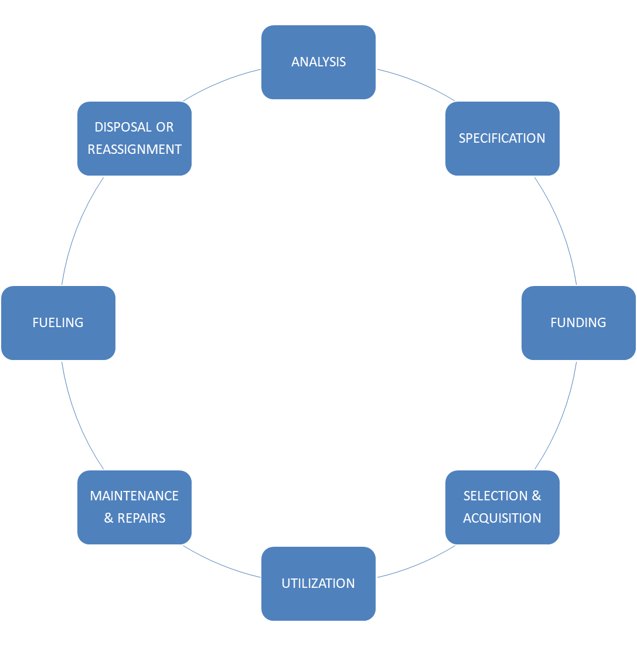

APPENDIX B: Vehicle Evaluation Form
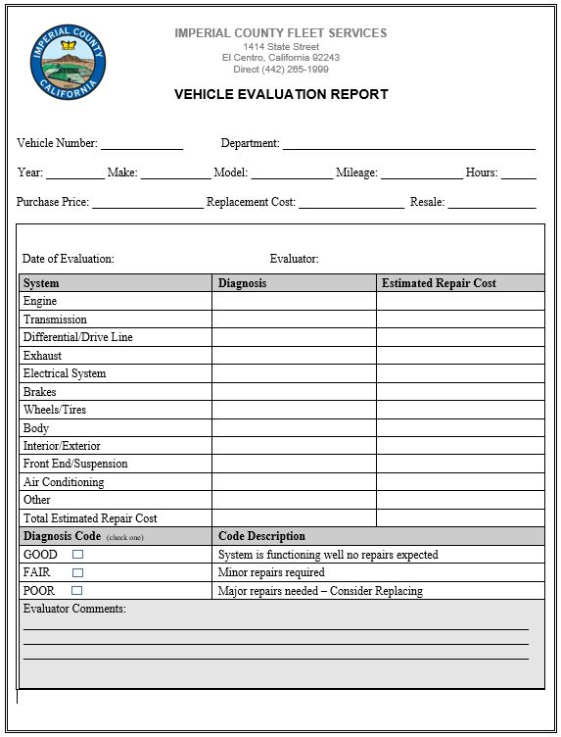

APPENDIX C: Vehicle Request Form

APPENDIX D: Vehicle Rate Schedule

AVAILABLE ON THE FLEET SERVICES WEBSITE

APPENDIX E: Verification of Self Insurance

AVAILABLE ON THE FLEET SERVICES WEBSITE

APPENDIX F: Mexico Insurance Policy

AVAILABLE UPON REQUEST
APPENDIX G: Waiver/Release of Liability

COUNTY OF IMPERIAL

WAIVER/RELEASE OF LIABILITY

PLEASE READ CAREFULLY BEFORE SIGNING.
THIS IS A RELEASE OF LIABILITY AND WAIVER OF CERTAIN LEGAL RIGHTS.

In consideration for being allowed to travel in a County vehicle on ______________ I hereby release the County of Imperial, its agents and employees from all claims for any and all liability for any injury, either real or perceived, suffered by the___________________ or any person associated with or attending this event___________________ arising from or connected with the gathering. The ___________________ assumes all risk from any injuries received.

The ____________________ also agrees to the fullest extent permitted by law to indemnify, defend, protect and hold the County of Imperial and its representatives, officers, directors, designees, employees, agents, successor and assigns harmless from any and all claims expenses, liabilities causes of action, demands, losses, penalties, attorney’s fees and costs, in law or equity, or every kind and nature whatsoever arising out of or in connection with the ________________________ participation in this gathering, including the Airport Cargo Feasibility Study negligent acts and omissions and/or willful misconduct, or the negligent acts and omissions and/or willful misconduct of any other persons associated with or attending the event.

I HAVE CAREFULLY READ THE ABOVE LIABILITY RELEASE AND SIGN IT WITH FULL KNOWLEDGE OF ITS CONTENTS AND SIGNFICANCE.

Signed: ___________________________________ Date: ______________________

Title: _____________________________________

Agency: __________________________________

APPENDIX H: Roadside Assistance Policy

The Fleet Services Roadside Assistance Policy provides a quick response to vehicle breakdowns and accidents. County employees are required to comply with provisions of the Roadside Assistance Policy.

1. Roadside Assistance Hours of Service
6 a.m. – 4 p.m. call Fleet Services (442) 265-1999
After 4 p.m. weekends and holidays call Sheriff Dispatch (442) 265-2021

2. Roadside Assistance Label
The Roadside Assistance Label will be placed on the vehicle dash in clear view of the driver.

ROADSIDE ASSISTANCE
6 a.m. – 4 p.m. Fleet Services (442) 265-1999
After 4 p.m. Sheriff Dispatch (442) 265-2021

3. Mechanical Problem
If you notice, a mechanical problem with a county vehicle report it immediately. Fleet Services will determine appropriate actions to either conduct roadside repairs or recover the vehicle. Unless the vehicle constitutes a traffic hazard in its current location, the driver shall not move it until instructed to do so.

4. Traffic Accident
Call 911 if anyone is injured. Report the traffic accident to the local law enforcement, supervisors and Fleet Services. Fleet Services will determine appropriate actions to recover the vehicle. Unless the vehicle constitutes a traffic hazard in its current location, the driver shall not move it until instructed to do so.

5. Vehicle Abandonment
Vehicles abandoned due to a mechanical problem or traffic accident report it immediately to Fleet Services during regular working hours or Sheriff Dispatch after hours. Secure the vehicle in a safe location, roll up the windows and lock all doors.

6. Driver Guidelines
- County employees shall follow the listed guidelines in the event of a vehicle mechanical problem or traffic accident.
- Call 911 if necessary
- Park the vehicle in a safe location
- Call your supervisor
- Call Fleet Services during regular business hours or Sheriff Dispatch after hours
- Stay with your vehicle if it is in a safe location
- Do not leave valuables in the vehicle
- Check in with your supervisor periodically until arrangements are made to pick you up
- Complete the Accident/Damage Report
7. Supervisor Guidelines
- County Department Supervisors shall follow the listed guidelines in the event of a reported vehicle breakdown or traffic accident.
- Call 911 if necessary.
- Call Fleet Services during regular business hours or Sheriff Dispatch after hours.
- Instruct the employee to park the vehicle in a safe location
- Immediately make arrangements to pick up your employee
- Call your employee periodically to ensure their safety
- Advise employee not to leave valuables unattended in the vehicle
- Complete the Supervisor Accident/Damage Report
8. Sheriff Dispatch Guidelines
Sheriff Dispatch shall follow the listed guidelines in the event of a reported vehicle breakdown or traffic accident.
- Call 911 or local emergency services if necessary
- Call your supervisor
- Call Fleet Service
- Call for towing service
9. Towing Service Request
Fleet Services or Sheriff Dispatch will be responsible for requesting the towing service.
10. Towing Service Guidelines
All county vehicles have the factory extended 36,000 mile/3 year warranty that includes roadside assistance. A sticker with an 800 number is on the driver’s side window or in the vehicle owner’s manual located in the glove box.

Towing service companies are authorized to make immediate repairs to the vehicle (lockouts, flat tire repair, winching, fuel delivery and jump-starts). If the vehicle cannot be repaired onsite, the vehicle will be towed in accordance to the Towing Service Response Area.

11. Towing Service Response Area
The towing service response area is assigned to three zones. (North County, South County and
Out of County).

- South County Roadside Assistance towing service south of Keystone Rd.
JT Towing (760) 355-1000. Deliver vehicles to the Fleet Services facility.
- North County Roadside Assistance towing service north of Keystone Rd.
Beach & Sons (760) 352-8009. Deliver vehicles to the Fleet Services facility.
- Out-of-County Roadside Assistance towing service
Pep Boys 24 Hour Roadside Assistance (800) 737-2697. Deliver to the nearest Pep Boys location.

The policy cannot address every scenario and county employees should use good judgement when a problem arises.

APPENDIX I: Vehicle Service Request

APPENDIX J: Motorpool Reservation Form

APPENDIX K: Vehicle Accident/Damage Report
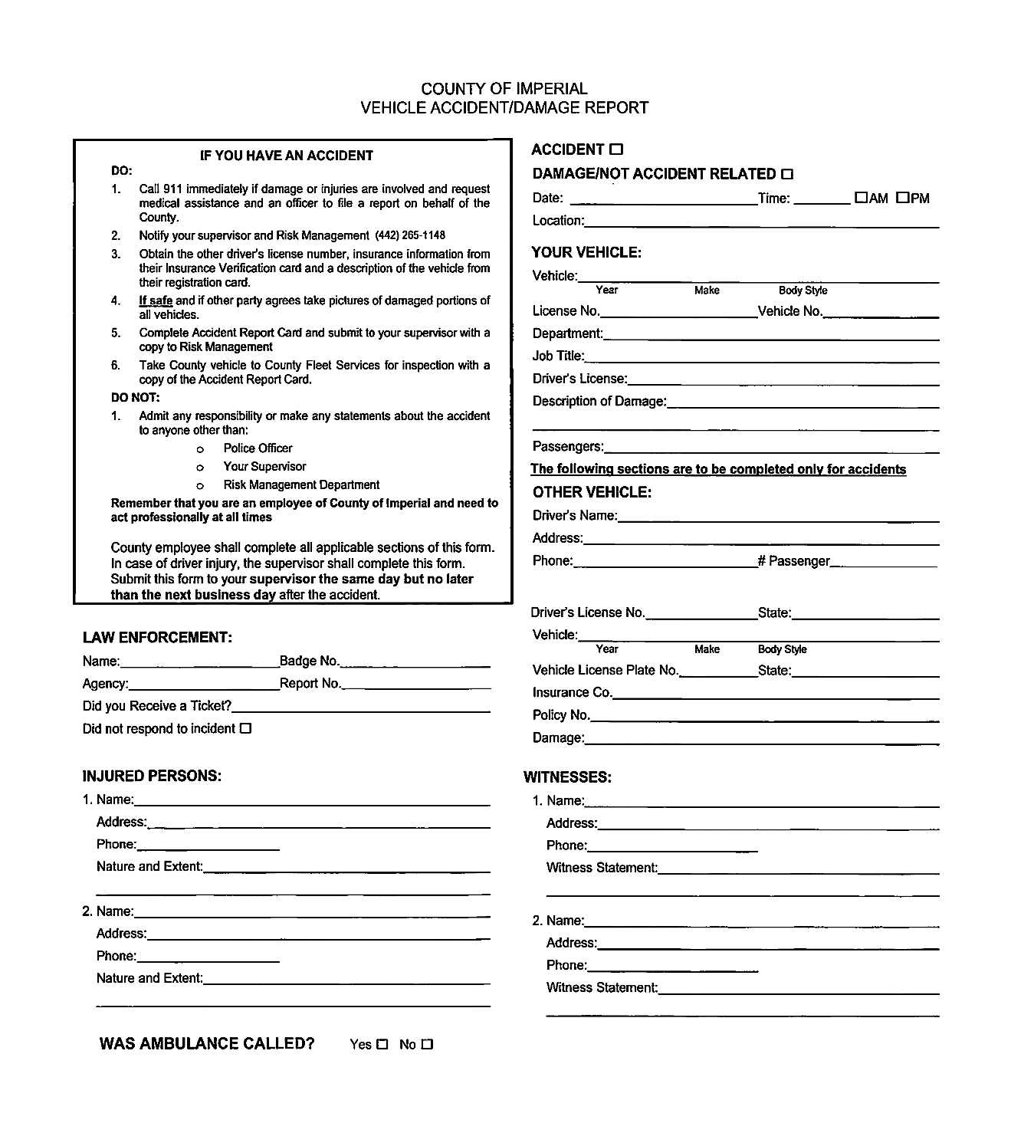

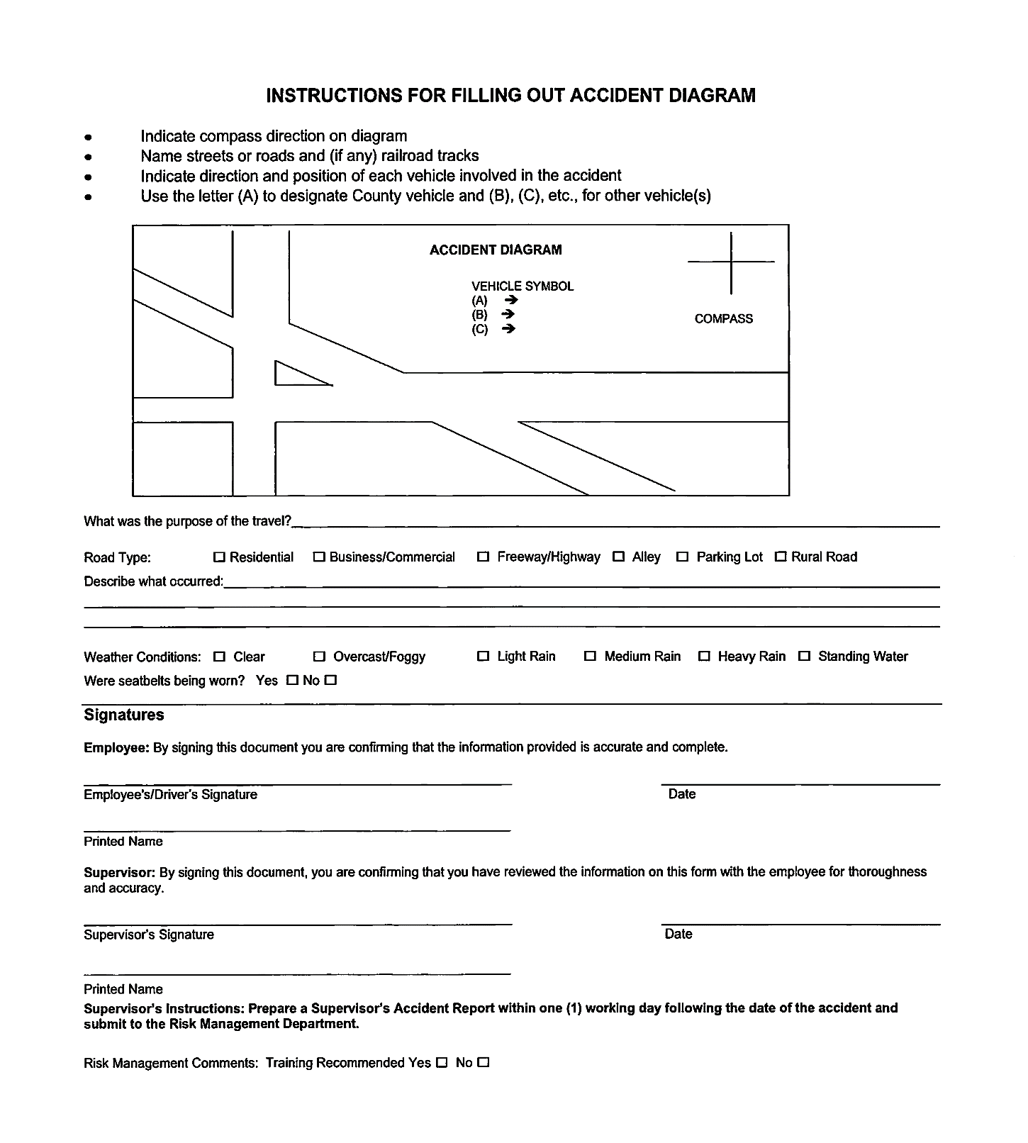

APPENDIX L: Supervisor’s Accident Investigation Report

APPENDIX M: Take Home Vehicle Assignment Form

This Page Intentionally Left Blank

